**MICROBIOLOGY SWAB COLLECTION**

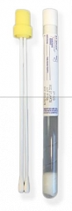

**YELLOW:** Throat culture

Genital culture

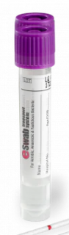

**PURPLE (eSwab):** Strep only

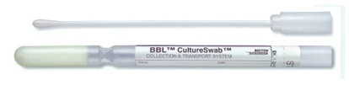

**WHITE:** Herpes

Varicella



**BLUE:** Wound Culture (anaerobic/aerobic)



**RED (COPAN):** MRSA (nasal only)

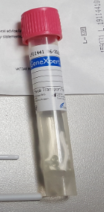

**PINK (Gene Xpert):** Gonorrhea;Chlamydia

Trichomonas



**Aptima Multitest:** Use for STD throat and rectal only

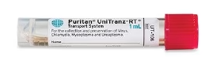

**RED (PURITAN):** RSV/Influenza A&B/Covid

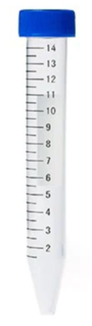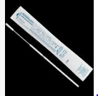

**Veritor KIT (consists of conical tube and swab):** Rapid Covid Only



**GREEN:** Bordetella Pertussis